CONCEPT MAP INSTRUCTIONS
Definition of a Concept Map: A concept map is a type of graphic organizer used to help students organize and represent knowledge of a subject. Concept maps begin with a main idea (or concept) and then branch out to show how that main idea can be broken down into specific topics. Probably the most important and enlightening aspect of any concept map is that it shows the relationships between the concepts on the map. Concepts can be written as words or drawn as images depending on the preference of the designer.
Here is a concept map that explains concept mapping!
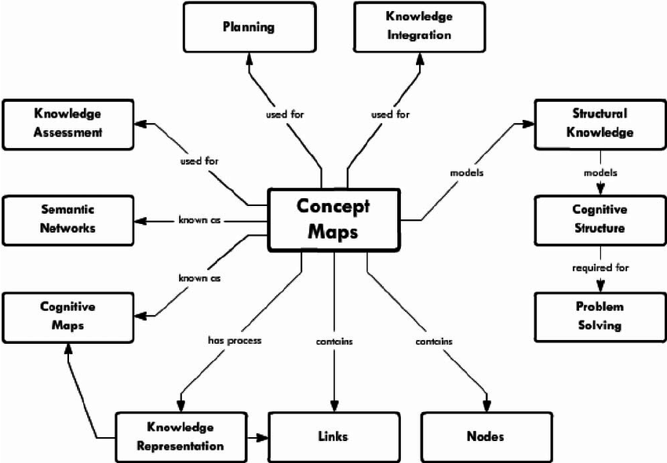

Below is a blank concept map to give you an idea about how you might get started. For example, your name could be in the middle oval of the map and the branching ovals or “nodes” can be the aspects of your life that make you who you are. The rectangles could describe the connections between the nodes. If you want to use drawings and lines with arrows to show nodes and connections, that’s helpful too!
Blank Concept Map

We are interested in your concept of yourself and how that relates to your academic plans and goals. Using the newsprint and markers/pens/colored pencils/crayons provided, please design a concept map using the nodes provided. There is no correct way to do this – this is YOUR concept map using YOUR ideas and creativity. We will collect these maps and revisit them with you at the end of this academic year to discuss how and why your concept of yourself and your academic goals have changed.
Tips:
- Consider all areas of your life and how they have influenced who and where you are today, i.e. family, friends, interests, hobbies, strengths, spirituality, ethnicity, gender, etc. Be sure to include all of the appropriate nodes on your map, but the academic goals you have today must be included on the map.
- How do these aspects of your life influence your academic goals and plans and how do they influence each other? These are the connections between the nodes that should be included in your map.
- You will be talking about and sharing your concept map with others in a small group so we can all get to know each other better, including your academic adviser.

